**History Of US Banking System**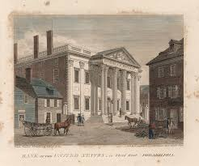

Early Banking in America (1780-1836)

The Bank of Pennsylvania and the Bank of North America

* The Bank of Pennsylvania was founded in 1780 to fund the American Revolutionary War.
* The Bank of North America was established in 1781 to facilitate more advanced banking transactions and provide a currency for the newly formed Thirteen Colonies.

The First and Second Banks of the United States

* The First Bank of the United States was chartered in 1791 and operated until 1811, when its charter was not renewed.
* The Second Bank of the United States was chartered in 1816 and operated until 1836, when its charter was also not renewed.
* These attempts to centralize banking regulation were met with fears of concentrated power and political corruption, leading to the non-renewal of their charters.

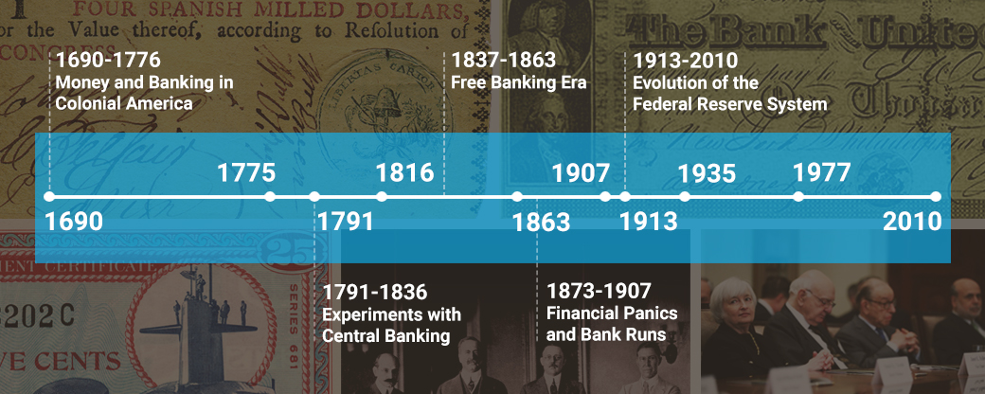

The National Banking System (1863-1913)

The National Banking Act of 1863

* Passed during the Civil War, the National Banking Act of 1863 aimed to replace state banks with nationally chartered ones.
* The Act created the Office of the Comptroller of the Currency (OCC) to oversee the new national banking system.
* The national banking system helped fund the war effort but was prone to panics, with a major one occurring in 1907.

The Federal Reserve System (1913)

The Creation of the Federal Reserve

* The Federal Reserve System was created in 1913 to serve as the central banking system of the United States.
* The Fed was designed to be decentralized, with 12 regional Federal Reserve Banks, to prevent concentration of power.
* The Fed's primary responsibilities include conducting monetary policy, supervising banks, and maintaining financial system stability.

The Great Depression and Reforms (1930s)

The Great Depression and Banking Reforms

* The Great Depression of the 1930s led to significant reforms in the banking industry.
* The Federal Deposit Insurance Corporation (FDIC) was created to insure deposits, protecting the interests of depositors.
* The Glass-Steagall Act was passed to separate commercial and investment banking, aiming to prevent future financial crises.

Deregulation and Re-regulation (1980s-2000s)

The Era of Deregulation

* The late 20th century saw a period of deregulation in the banking industry, with the repeal of the Glass-Steagall Act in 1999.
* This allowed for greater integration between commercial and investment banking, leading to the growth of large, diversified financial institutions.

The Subprime Mortgage Crisis and Re-regulation

* The subprime mortgage crisis and Great Recession of the 2000s led to a re-regulation of the banking industry.
* The Dodd-Frank Wall Street Reform and Consumer Protection Act of 2010 was enacted to address the shortcomings of the previous regulatory framework and to prevent future financial crises.

Current State of the U.S. Banking System

* The U.S. banking system is highly influential globally, centered in New York City and Wall Street.
* It is regulated at both the federal and state levels by various agencies and laws, including the Federal Reserve, the FDIC, and the OCC.

Conclusion

The history of the U.S. banking system is a testament to the resilience and adaptability of the financial sector. From its humble beginnings to its current global influence, the system has undergone significant transformations, driven by economic, political, and social factors. Understanding this history is crucial for navigating the complex landscape of modern banking and finance.